JD521 Summitive

6955 Laikin Barnard

Contents

Question: 2

Code: 3

Solution: 5

Result: 6

Passing result: 6

Failing result: 7

# Question:

Create a two-dimensional array of type double to contain the three different SD Marks (JD521, PRG521, and IP521) for six different students. A single array of type String must be used to store the student names (Maxwell, Carl, Gerhard, Paul, James, and Cena).

Allow a user to enter in a number, ranging from 1 to 6, which will represent the student position in the table MCSD max and present the marks for each respecting module. The program can only stop when the user enter a number greater than 6.

Printout the student name including the JD521, PRG521, and IP521 max, the total of marks and the average of all marks. Use a condition statement to decide that the student has passed or not (Pass rate is 70).

|  |  |  |  |
| --- | --- | --- | --- |
| Student name | JD521 | PRG521 | IPG521 |
| Maxwell | 80 | 65 | 70 |
| Carl | 95 | 70 | 65 |
| Gerhard | 87 | 80 | 73 |
| Paul | 65 | 45 | 60 |
| James | 45 | 87 | 65 |

# Code:

/*Laikin Barnard 6955*/

package Question21;

import javax.swing.*;

public class Question21_6955 {

public static void main(String[] args) {

// Names Single array declaration

String[] ArrNames = {"Maxwell", "Carl", "Gerhard", "Paul", "James", "Cena"};

// SDMarks Multidimensional array declaration

String[] module = {"JD521","PRG521","IP521"};

double[][] ArrSDMarks = {

{80, 65, 70},

{95, 70, 65},

{87, 80, 73},

{65, 45, 60},

{45, 87, 65},

{90, 50, 70}

};

//Calculates number of rows and columns present in given array

int sumRow = 0;

int m =Integer.parseInt( JOptionPane.showInputDialog("Which student marks do you wanna see? "));

System.out.println(ArrNames[m-1]+ " Your grades are as follows: ");

for (int i = 0; i <6; i++){

for (int z = 0; z < 3; z++){

if ( i == m-1 ){

System.out.println(module[z]+ " : "+ArrSDMarks[i][z]);

sumRow += ArrSDMarks[i][z];

}

}

}

// Avg and Mark Total

double Total = sumRow;

double Avg = Total*0.3;

System.out.println("Your total mark out of 300 is : " + Total);

System.out.println("Your Avrage mark is : " + Avg);

// Conditioning to determine a pass or fail.

if (Avg >= 70) {

System.out.println("You pass!");

}

else {

System.out.println("You failed...");

}

}

}

# Solution:

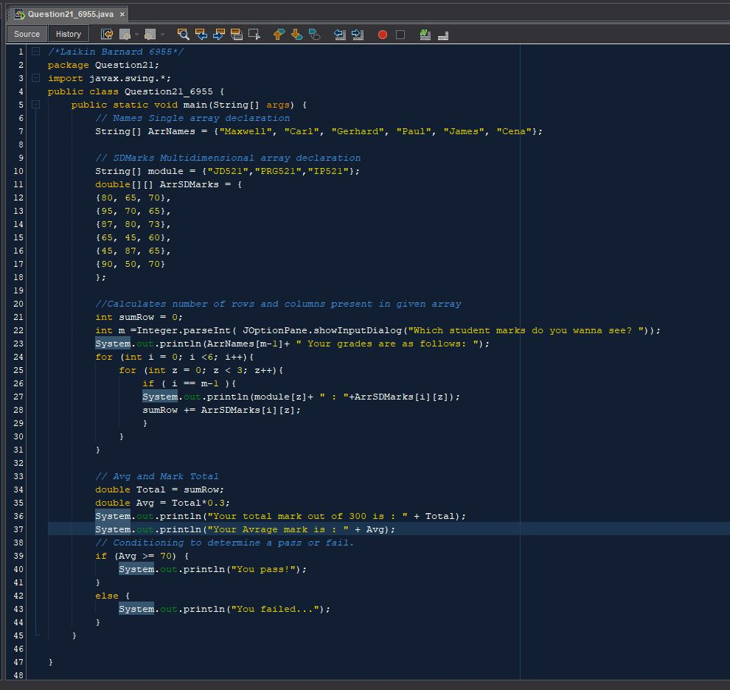

# Result:

## Passing result:

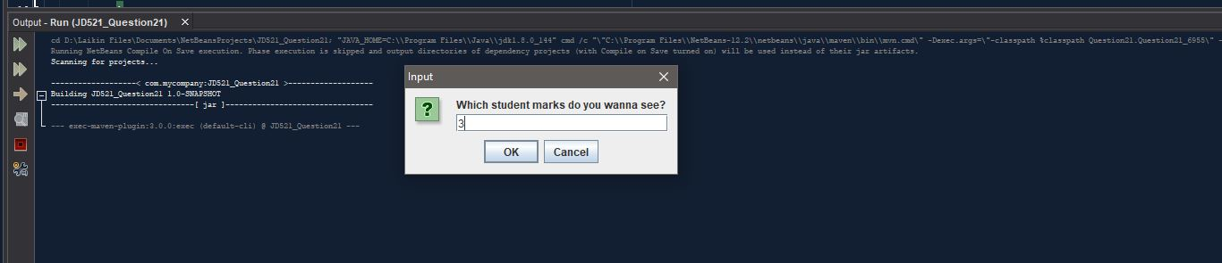

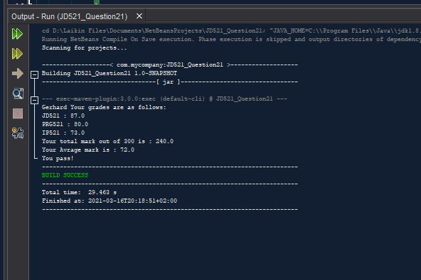

## Failing result:

